**ASSIGNMENT I**

**BIT 302**

**Software Engineering**



**Project Proposal**

**Covid Testing Information System (CTIS)**

**Prepared by:**

Team Leader: Pande Putu Rama Pratama Putra (E1700877)

I Nengah Wahyudi Setiawan (E1700868)

Contact Details:

[ramapratama657@gmail.com](mailto:ramapratama657@gmail.com)

nengahwahyudi90[@gmail.com](mailto:sidi.meisanjaya2013@gmail.com)

2021/2022

Table of Contents

Overview 3

Project Aims 4

Project Objects 4

Project Scope 5

Project Schedule 6

Work Breakdown Structure 8

Milestones/Deliverables 10

Baselines Gantt Charts 10

Technical Description of the Proposed System 12

Development Platform 12

Demonstration Platform 13

Risk Management Plan 14

References 17

Overview

Corona virus or “Severe Acute Respiratory Syndrome Coronavirus 2” (SARS-CoV-2) is a virus that attacks the respiratory system. This disease due to viral infection is called COVID-19. The Corona virus can cause minor disorders of the respiratory system, severe lung infections, and death. Corona virus infection is called COVID-19 (Corona Virus Disease 2019) and was first discovered in the city of Wuhan, China at the end of December 2019. This virus is spreading very quickly and has spread to almost all countries, including Indonesia, in just a few months.

During this pandemic, there are hundreds to millions of thousands of people who have tested positive for Covid. For doctors and health experts, it is a very large number and it is undeniable that each medical center controls patients who are divided from those who are positive for Covid, are currently in quarantine, are suspended, and who have recovered from Covid. Our motivation is to want to help each medical center to manage every covid history for each patient, controlling the growth of this Covid case. So we want to make a website application which is aimed at each medical center to make it easier to control and store the test results of each patient who has visited the medical center.

In addition, we also want to make this website application to help patients track their status history and get important info about Covid. For now, there are already several covid testing information system applications in each country and each country has different functions in presenting this application, and for Indonesia, there is a website application which can register everyone to get this Covid vaccine. However, until now there is no application that makes it easier for every medical center and patients to track the covid history. The cost required in making this application is Rp. The duration of making this application is 3 months to complete this application

Project Aims

* To help medical center for manage every patients were have positive Covid, in Quarantine, suspended, or recovered from Covid.
* To create a system that updates the patient’s status database that generates from administrator.
* To make clear all information about all data and patients can see their status about Covid.

Project Objects

* Gather all Documents, data, and all the information that useful for this project.
* Find and use the tools and software programming language that suitable and useful for develop this project.
* Create a website application with easy – to – use interface.
* Create a Database and input all the data and information that has been collected.
* Intergrating the Website and Database to build this website application.

Project Scope

|  |
| --- |
| **Project Title:** Covid Testing Information System (CTIS)  **Date:** February 8 , 2021  **Prepared by:** Rama Pratama, Project Team Leader, ramapratama657@gmail.com |
| **Project Summary and Justification:**  In this Website Application, we want to help medical center for make it easier to handle patients Covid. With attractive interface and easy – to – use, and features available that useful for administrator and patients(user) for manage and generates their status report. |
| **Product Characteristics and Requirements:**   1. Attractive and easy – to – use features and interfaces for administrators and user that can check status report Covid. And also, administrator can update report status for patients. 2. All features in this website application must tested before to avoid things like errors and bugs 3. Make sure for the program can run properly and efficiency. |
| **Summary of Project Deliverables**  **Project management-related deliverables:** Project Aims, Project Objectives, Project Scope Statement, WBS (Work Breakdown Structure), Schedule, Cost Baseline, Requirements Specification Document, Design and Testing Documentation, Website-based Covid Testing Information System that is useful and can work, Final Project Presentation required to manage the project.  **Product-related deliverables:**   1. Website Application Covid Testing Information System managed and accessed by administrators from medical center. Information system for user that can be accessed anytime and anywhere. 2. The content on this website contains features to recap and manage and know the data of each User’s history status and data. 3. Web appearance will be made simple and easy – to – use by ordinary people, so that users and administrator are comfortable when using it. |
| **Project Success Criteria:**  This project will be completed in 3 months. The success of this project is measured by the requirements and all characteristics. This project can greatly help many people, including medical center and the user(patients). Also, The information system will develop rapidly because it is very much used in this era of the Corona pandemic. |

Project Schedule

|  |  |  |  |  |  |  |
| --- | --- | --- | --- | --- | --- | --- |
| **Schedule** | **Start Date** | | **End Date** | | **Estimate Days** | **Responsible** |
| **Initiating Task** | | | | | | |
| Determining Topic | Mon, 01/02/2021 | | Mon, 01/02/2021 | | 1 | All |
| Overview Project | Tue, 02/02/2021 | | Thu, 04/02/2021 | | 3 | Wahyudi |
| Analysis Project Aims and Project Objective | Tue, 02/02/2021 | | Thu, 04/02/2021 | | 3 | Rama |
| Project Scope | Mon, 08/02/2021 | | Wed, 10/02/2021 | | 3 | All |
| Complete Initiating Task (Milestones) | Thu, 11/02/2021 | | Thu, 11/02/2021 | | 0 | All |
| **Planning Task** | | | | | | |
| Work Breakdown Structure | Fri, 12/02/2021 | | Sat, 13/02/2021 | | 2 | Wahyudi |
| Develop Deliverables | Fri, 12/02/2021 | | Sat, 13/02/2021 | | 2 | Rama |
| Baseline Gantt Chart | Mon, 15/02/2021 | | Tue, 16/02/2021 | | 2 | Rama |
| Resource Planning | Wed, 17/02/2021 | | Mon, 22/02/2021 | | 6 | All |
| Risk Management Plan | Tue, 23/02/2021 | | Thu, 25/02/2021 | | 3 | Wahyudi |
| Requirements Definition | Fri, 26/02/2021 | | Mon, 01/03/2021 | | 4 | All |
| Use Case Diagram | Tue, 02/03/2021 | | Wed, 03/03/2021 | | 2 | Wahyudi |
| Class Diagram and Work Division | Tue, 02/03/2021 | | Wed, 03/03/2021 | | 2 | Rama |
| System Sequence Diagrams and Contracts | Thu, 04/03/2021 | | Sat, 06/03/2021 | | 3 | All |
| Set Up GitHub | Mon, 08/03/2021 | | Tue, 09/03/2021 | | 2 | All |
| Assignment 1 Submission (Milestones) | Wed, 10/03/2021 | | Wed, 10/03/2021 | | 0 | All |
| **Executing Task** | | | | | | |
| Develop Site Map | Thu, 11/03/2021 | | Fri, 12/03/2021 | | 2 | Rama |
| Design Class Diagram | Thu, 11/03/2021 | | Fri, 12/03/2021 | | 2 | Wahyudi |
| Updating System Sequence Diagram | Mon, 15/03/2021 | | Tue, 16/03/2021 | | 2 | All |
| ERD and Database | Wed, 17/03/2021 | | Fri, 19/03/2021 | | 3 | All |
| Wire Frames | Mon, 22/03/2021 | | Tue, 23/03/2021 | | 2 | All |
| Develop Prototype 1 | Wed, 24/03/2021 | | Mon, 29/03/2021 | | 6 | All |
| Produce Prototype 1 (Milestones) | Tue, 30/03/2021 | | Tue, 30/03/2021 | | 1 | All |
| **Iteration 1** | | | | | | |
| Test Objectives | Wed, 31/03/2021 | | Wed, 31/03/2021 | | 1 | All |
| Develop Test Plan | Thu, 01/04/2021 | | Fri, 02/04/2021 | | 2 | Rama |
| Produce Test Result | Mon, 05/04/2021 | | Mon, 05/04/2021 | | 1 | Wahyudi |
| Analysis Report | Mon, 05/04/2021 | | Mon, 05/04/2021 | | 1 | Rama |
| Presentation Preparation | Tue, 06/04/2021 | | Wed, 07/04/2021 | | 2 | All |
| Presentation and Assignment 2 (Milestones) | Thu, 08/04/2021 | | Thu, 08/04/2021 | | 1 | All |
| Problem Solutions | Fri, 09/04/2021 | | Fri, 09/04/2021 | | 1 | All |
| Analysis/Design Updates | Mon, 12/04/2021 | | Mon, 12/04/2021 | | 1 | All |
| Develop Prototype 2 | Tue, 13/04/2021 | | Fri, 16/04/2021 | | 4 | All |
| Produce Prototype 2 (Milestones) | Sat, 17/04/2021 | | Sat, 17/04/2021 | | 0 | All |
| **Iteration 2** | | | | | | |
| Test Objectives | Sat, 17/04/2021 | | Mon, 19/04/2021 | | 2 | All |
| Update Test Plan | Tue, 20/04/2021 | | Tue, 20/04/2021 | | 1 | Wahyudi |
| Produce Test Resource | Wed, 21/04/2021 | | Wed, 21/04/2021 | | 1 | All |
| Test Analysis Report | Thu, 22/04/2021 | | Thu, 22/04/2021 | | 1 | Rama |
| Produce Conclusion | Fri, 23/04/2021 | | Fri, 23/04/2021 | | 1 | All |
| **Monitoring and Controlling Task** | | | | | | |
| Update Gantt Chart 1 | | Mon, 05/04/2021 | | Tue, 06/04/2021 | 2 | All |
| Update Gantt Chart 2 | | Thu, 22/04/2021 | | Thu, 22/04/2021 | 1 | All |
| **Closing Task** | | | | | | |
| Presentation Preparation | | Sat, 24/04/2021 | | Tue, 27/04/2021 | 4 | All |
| Presentation and Assignment 3 Submission (Milestones) | | Wed, 28/04/2021 | | Wed, 28/04/2021 | 0 | All |

Work Breakdown Structure

1. Initiating Task
   1. Determining Topic
   2. Overview
   3. Analysis Project Aims and Project Objectives
   4. Project Scope
   5. Complete Initiating Task (Milestones)
2. Planning Task
3. Work Breakdown Structure
4. Develop Deliverables
5. Baseline Gantt Chart
6. Resource Planning
7. Risk Management Plan
8. Requirements Definition
9. Use Case Diagram
10. Class Diagram and Work Division
11. System Sequence Diagram and Contracts
12. Set Up GitHub
13. Assignment 1 Submission (Milestones)
14. Executing Task
15. Develop Site Map
16. Designing Class Diagram
17. Updating System Sequence Diagram
18. ERD and Database
19. Wire Frames
20. Develop Prototype 1
21. Produce Prototype 1 (Milestones)
22. Iteration 1
    * 1. Test Objectives
      2. Develop Test Plan
      3. Produce Test Result
      4. Analysis Report
    1. Presentation Preparation
    2. Presentation and Assignment 2 (Milestones)
    3. Problems Solutions
    4. Analysis/Design Updates
    5. Develop Prototype 2
    6. Produce Prototype 2 (Milestones)
    7. Iteration 2
       1. Test Objectives
       2. Update Test Plan
       3. Produce Test Result
       4. Test Analysis Report
       5. Produce Conclusion
23. Monitoring and Controlling Task
24. Update Gantt Chart 1
25. Update Gantt Chart 2
26. Closing Task
27. Presentation Preparation
28. Presentation and Assignment 3 Submission (Milestones)

Milestones/Deliverables

|  |  |  |  |
| --- | --- | --- | --- |
| **No.** | **Milestones Name** | **Phase** | **Expected Completion Date** |
| 1 | Complete Initiating Task | Initiating Task | February 11, 2021 |
| 2 | Assignment 1 Submission | Planning Task | March 10, 2021 |
| 3 | Produce Prototype 1 | Executing task | March 30, 2021 |
| 4 | Presentation and Assignment 2 | Executing task | April 08, 2021 |
| 5 | Produce Prototype 2 | Executing task | April 17, 2021 |
| 6 | Presentation and Assignment 3 Submission | Closing Task | April 28, 2021 |

Baselines Gantt Charts

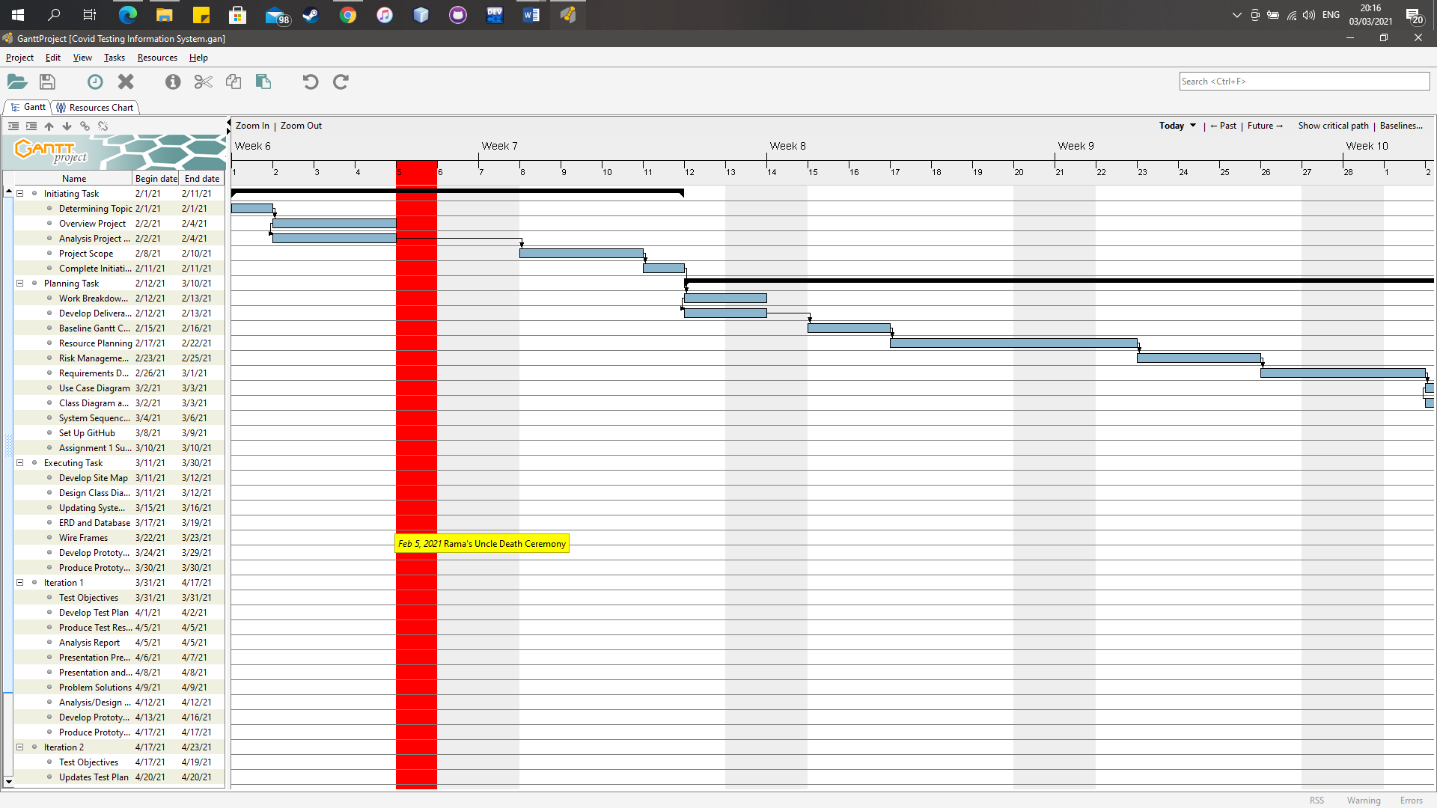

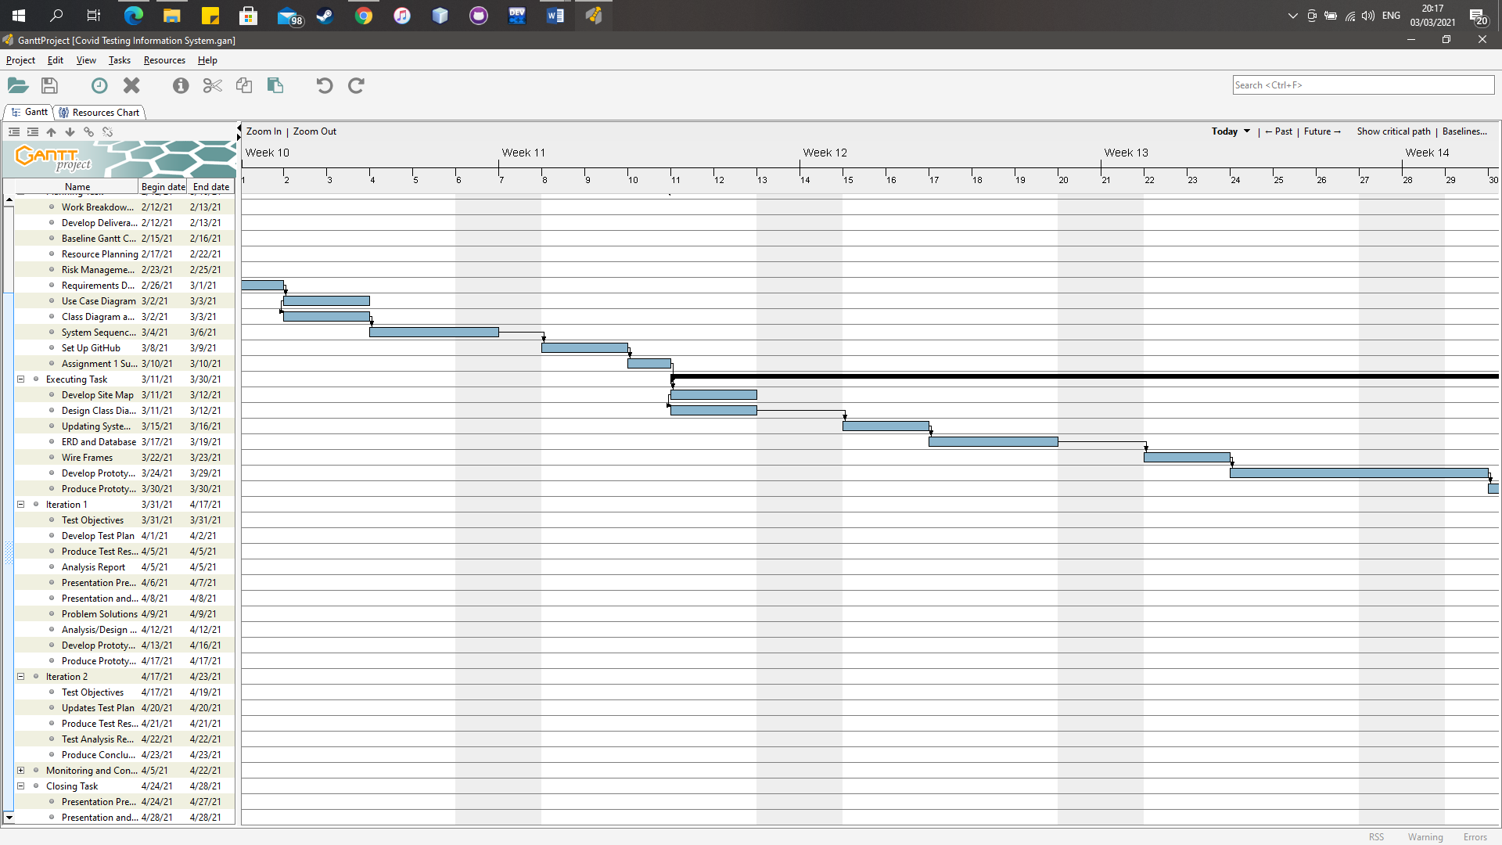

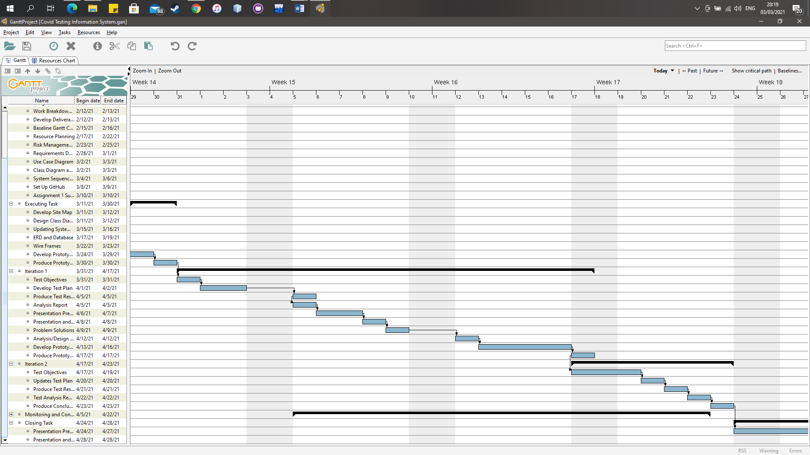

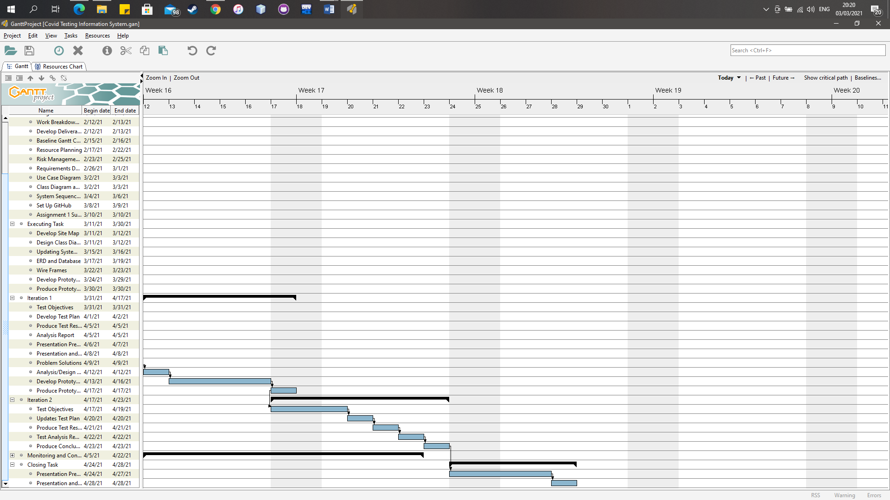

Technical Description of the Proposed System

Development Platform

Software:

* 1. **Laragon**

Is a universal development environment. It used to build and manage web application.

* 1. **Adobe DreamWeaver**

Is a application IDE for write and edit code that create the project website application

* 1. **Code Igniter**

Is a PHP Framework that suitable for develop website

* 1. **Heidi SQL**

Is a client tool that used for MySQL as well as Microsoft SQL server

* 1. **Microsoft Visio**

Is a application for create an diagram like UseCase Diagram, Sequence Diagram.

* 1. **Gantt Project**

Is a application that create Gantt Charts for scheduling of project

* 1. **Microsoft Word**

Is a application for create documentation and reports for this project

* 1. **Microsoft Powerpoint**

Is a application for create presentation that use for show the project

* 1. **Google Chrome**

It used for for search resources and information that needed on this project and also it used for testing the project

* 1. **Github**

Is a application that can control the code’s project from this team member

* 1. **Line**

Is a application for communication media with team member

**Hardware:**

1. Laptop

We use Laptop for make this Website Application Project. Also, we use Windows operating system because Windows is the most used Operating System by the most people.

Demonstration Platform

**Software:**

1. Google Chrome

We use Google Chrome for demonstrate the Website Application because Google Chrome are the Web Browser that most used by the most people.

**Hardware:**

1. Laptop

We use laptops for testing Website Applications. Just standard laptop that have standard specifications because we want this Website Application can run smoothly.

Risk Management Plan

|  |  |  |  |  |  |  |  |  |  |  |  |
| --- | --- | --- | --- | --- | --- | --- | --- | --- | --- | --- | --- |
| **No** | **Rank** | **Risk** | **Description** | **Category** | **Root**  **Cause** | **Triggers** | **Potential**  **Responses** | **Risk Owner** | **Probability** | **Impact** | **Status** |
| 1 | 1 | Lack of understanding and experience in working on projects to develop websites | Lack of experience and understanding from team member to develop website and the requirement | Process Risk | Lack of experience and understanding to the requirement needed to develop the project | Lack of discussion with team and lecturer. | Discuss with team and lecturer | Team Member and Team Leader | High | High | Open |
| 2 | 2 | Lack communication between team member and team leader | Team member and team leader did not communicate sufficiently in discussing the continuation of the project | People Risk | Team member tends to choose to work alone in continuing the project and team members do not reply Team Leader's chat because the team members have not completed his task. | Team member tends to work alone because they think his task can be completed in a short time and don't care about other tasks. | Communicate more often with the team leader and faster respond to calls or chats so the team leader can know the progress of the task. Team member should not underestimate the task and ask team member about the unfinished task | Team Member | High | High | Open |
| 3 | 3 | Website function does not run according to the plan | Completed or not completed function do not run as intended and get error | System Risk | Difficulty to finish the function because of lack experience | Website function error and do not work as the plan | Learn and find solution from available resources | Team Member and Team Leader | High | High | Open |
| 4 | 4 | Can not submit the project on time | Unable to submit projects on time due to unfinished tasks, having difficulty creating a website, and connection problem | Process Risk | Lack of time to complete the project on time. | Task and website development takes more time than expected from the schedule. | Find the solution for the problem and follow the schedule. | Team Member and Team Leader | High | High | Open |
| 5 | 5 | Bug in the Website | There is bug in the website that will make website can not function properly. | System Risk | There are mistake and error in the website development | Not checking when making the website | Search and learn available source to avoid making some mistakes | Team Member and Team Leader | High | High | Open |

References

O’Neil ,Patrick Howell, Tate Ryan-Mosley, and Bobbie Johnson. 2020. A Flood of coronavirus apps are tracking us. Now it’s time to keep track of them. MIT Technology Review. https://www.technologyreview.com/2020/05/07/1000961/launching-mittr-covid-tracing-tracker/

Kementrian Komunikasi dan Informatika. 2020. PeduliLindungi. https://pedulilindungi.

**ASSIGNMENT I**

**BIT 302**

**Software Engineering**



**Project Proposal**

**Covid Testing Information System (CTIS)**

**Prepared by:**

Team Leader: Pande Putu Rama Pratama Putra (E1700877)

I Nengah Wahyudi Setiawan (E1700868)

Contact Details:

[ramapratama657@gmail.com](mailto:ramapratama657@gmail.com)

nengahwahyudi90[@gmail.com](mailto:sidi.meisanjaya2013@gmail.com)

2021/2022

Table of Contents

Functional requirements 3

Non – Functional Requirements 3

Use Case Diagram 4

Analysis Class Diagram 6

Expanded Use Case 6

Task Division 12

System Sequence Diagram 13

Contracts 21

Functional requirements

In the website there will be several menus:

* Register Test Center

This menu can be access by Test Centre Manager. It allows Test Centre Manager to register Test Centre’s name.

* Record Tester

This menu can be access by Test Centre Manager. It allows Test Centre Manager to set and record the centre officer position as “Tester”.

* Manage Test Kit Stock

This menu can be access by Test Centre Manager. It allows Test Centre Manager to manage the stock of test kits.

* Generate Test Report

This menu can be access by Test Centre Officer. It allows Test Centre Officer to display the history of all tests report.

* Record New Test

This menu can be access by Tester. It allows Tester to record the patient that have taken a test.

* Update Test Result

This menu can be access by Tester. It allows Tester to update the results of a test from the patient and patient can view the result.

* View Testing History

This menu can be access by Patent. It allows Patient to view all history of tests that have been taken.

Non – Functional Requirements

* Provide accurate information

Accurate, precise, and mus be appropriate that the data entered by the admin

* Easy to use

The system must have simple and easy-to-use interface, so the user will be easier to use

* Modifiability

Administrator can edit all the data like testID, status, etc. Only user can view their status

Use Case Diagram

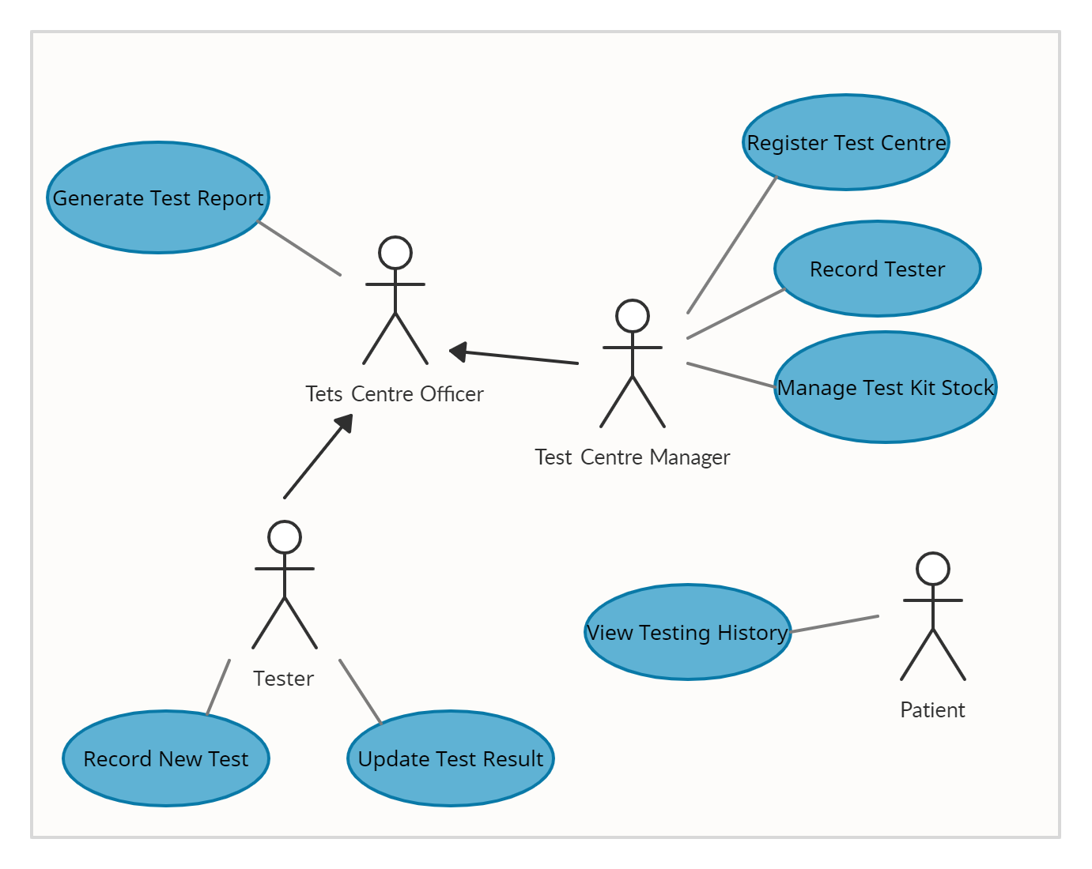

Use Cases

|  |  |  |
| --- | --- | --- |
| Use Case | Actor | Requirement |
| Register Test Centre | Test Centre Manager | Page for Test Centre Manager in register the Test Centre. |
| Record Tester | Test Centre Manager | Page for Test Centre Manager in record a new Test Centre Officer with position “Tester”. |
| Manage Test Kit Stock | Test Centre Manager | Page for Test Centre Manager to manage the stock of test kits. |
| Generate Test Report | Test Centre Officer | Page for Test Centre Officer to display history all test that have been administered the officer. |
| Record New Test | Tester | Page for Tester to record a patient that has taken a test. |
| Update Test Result | Tester | Page for Tester to update the test result from patient. |
| View Testing History | Patient | Page for Patient to view all history of test that have been taken. |

Analysis Class Diagram

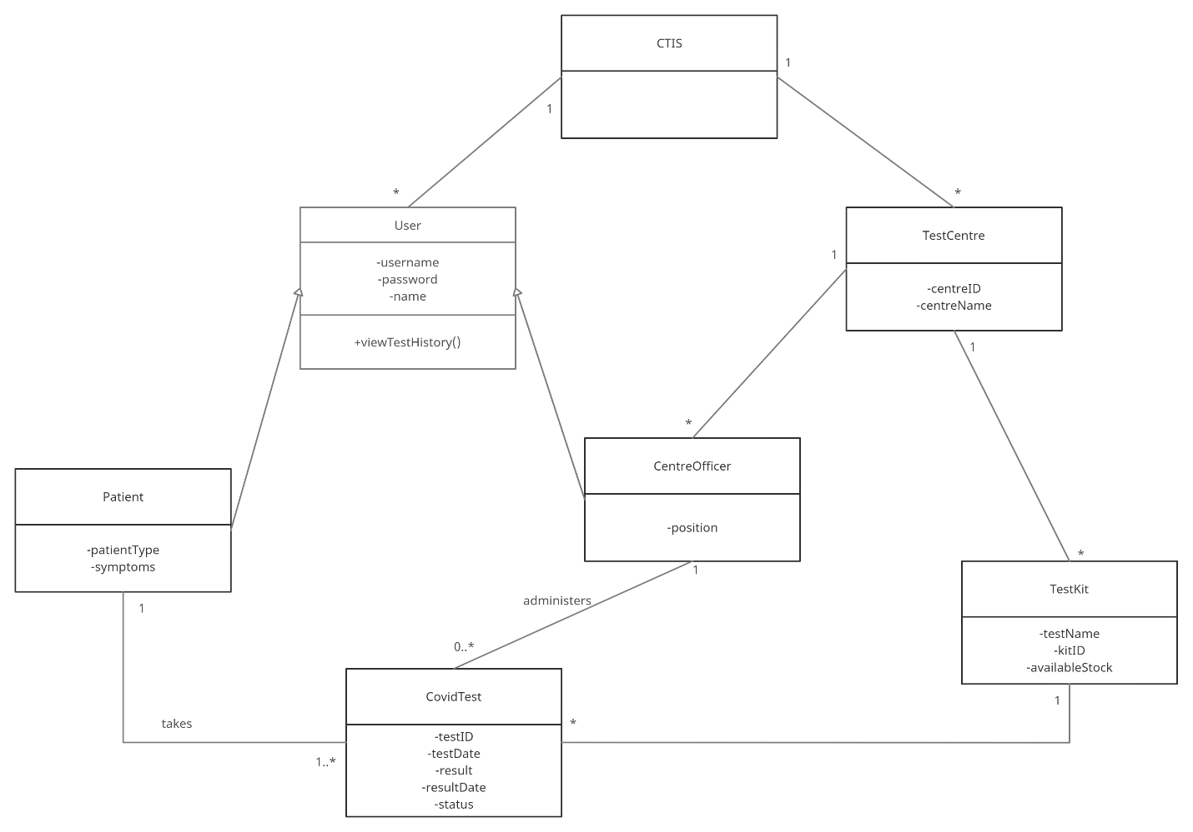

Expanded Use Case

|  |  |
| --- | --- |
| **Use Case 1** | Register Test Centre |
| **Goal in Context** | To allow Test Centre Manager register Test Centre’s name |
| **Primary Actor**  **Secondary Actor** | Test Centre Manager |
| **Trigger** | Test Centre has been approved and Test Centre Manager’s account has been set up as a centre officer |
| **Typical Course of Events Actor Action** | **System Response** |
| 1. This use case starts when the Test Centre Manager wants to register the centre’s name. |  |
| 1. The Test Manager logs in to register the centre’s name. | Test centre’s name is registered. The centreID is created automatically and recorded. |
| **Alternative Course of Events** | |

|  |  |
| --- | --- |
| **Use Case 2** | Record Tester |
| **Goal in Context** | To allow Test Centre Manager set and record the centre officer position as “Tester” |
| **Primary Actor**  **Secondary Actor** | Test Centre Manager |
| **Trigger** | The Test Centre Manager wants to record a new Test Centre Officer with the position ‘tester’. |
| **Typical Course of Events Actor Action** | **System Response** |
| 1. This use case starts when the Test Centre Manager wants to record a new Test Centre Officer’s position with “Tester”. |  |
| 1. The Test Manager logs in to records the username, password, and name of the officer and set the position to “Tester”. | The Test Centre Officer that have been recorded is set as “Tester”. |
| **Alternative Course of Events**  **Line 2:** If there another record new Centre Officer to set the position is “Tester”, repeat line 2. | |

|  |  |
| --- | --- |
| **Use Case 3** | Manage Test Kit Stock |
| **Goal in Context** | To allow Test Centre Manager able to manage the stock of test kits |
| **Primary Actor**  **Secondary Actor** | Test Centre Manager |
| **Trigger** | The Test Centre Manager receives new stock of test kits |
| **Typical Course of Events Actor Action** | **System Response** |
| 1. This use case starts when the Test Centre Manager wants to manage the stock of test kits |  |
| 1. The Test Manager logs in to records the test kit name and stock | The Test Kit name and stock is recorded and kitID is generated |
| **Alternative Course of Events**  **Line 2:** If there is existing stock for a given kitID, the stock of the Test Kit is updated | |

|  |  |
| --- | --- |
| **Use Case 4** | Generate Test Report |
| **Goal in Context** | To allow Test Centre Officer able to display the history all tests report |
| **Primary Actor**  **Secondary Actor** | Test Centre Officer |
| **Trigger** | The Test Centre Officer wants to view a test report |
| **Typical Course of Events Actor Action** | **System Response** |
| 1. This use case starts when the Test Centre Officer wants to view a test report |  |
| 1. The Test Officer logs in with a username and password | The Test Officer successfully logs in and display all history of test report that have been administered |
| **Alternative Course of Events**  **Line 2:** If the username and password of Test Centre Officer is incorrect, system will display alert about incorrect | |

|  |  |
| --- | --- |
| **Use Case 5** | Record New Test |
| **Goal in Context** | To allow Tester record the patient |
| **Primary Actor**  **Secondary Actor** | Tester |
| **Trigger** | The Tester wants to record a patient that has been taken a test |
| **Typical Course of Events Actor Action** | **System Response** |
| 1. This use case starts when the Tester wants to record a patients |  |
| 1. The Tester logs in with a username and password | The Tester successfully logs in |
| 1. The Tester records username, password, name, patient type, and symptoms for the patient | Successfully records data for the patient. The date of the test and the testID is automaticaly generated. The status of the test is “Pending” |
| **Alternative Course of Events**  **Line 2:** If the Test Centre Officer’s position is not “Tester”, system will display alert incorrect username and password, and tesrerthe officer can not record the data of the patient.  **Line 3a:** If the Patient has taken a test before, the Tester updates the patient type and symptoms only. The date of the test and the testID is automaticaly generated. The status of the test is “Pending”  **Line 3b:** If the Tester is not fulfill the data of the patient, the system will not successfully record data of the patient**.** | |

|  |  |
| --- | --- |
| **Use Case 6** | Update Test Result |
| **Goal in Context** | To allow Tester update the results of a test from the patient and patient can view the result |
| **Primary Actor**  **Secondary Actor** | Tester |
| **Trigger** | The result of the test is received and The Tester want to update the results of the test |
| **Typical Course of Events Actor Action** | **System Response** |
| 1. This use case starts when The Tester want to update the results of a test |  |
| 1. The Tester logs in with a username and password | The Tester successfully logs in |
| 1. The Tester enters the testID | Successfully retreive the test details |
| 1. The Tester enters the results and result date | Successfully record the results and the result date. The status of the test is “Complete” |
| **Alternative Course of Events**  **Line 3:** If the Tester input wrong testID, it will not display the Patient’s data and can not update the results of the test.  **Line 4:** If the Tester is not fulfill the results and result date, the system will not successfully record data of the patient**.** | |

|  |  |
| --- | --- |
| **Use Case 7** | View Testing History |
| **Goal in Context** | To allow Patient view all history of tests that have been taken |
| **Primary Actor**  **Secondary Actor** | Patient |
| **Trigger** | The patient want to view the results of the tests |
| **Typical Course of Events Actor Action** | **System Response** |
| 1. This use case starts when The Patient want to view the results of the tests |  |
| 1. The Patient logs in with a username and password | Patient successfully logs in and display all the history of the tests |
| **Alternative Course of Events**  **Line 2:** If the Patient input wrong username and password, it will not display the history of all the tests. | |

|  |  |
| --- | --- |
| **Use Case 8** | Login |
| **Goal in Context** | To allow user to login as their status positions |
| **Primary Actor**  **Secondary Actor** | All user |
| **Trigger** | User wants to logs in to website |
| **Typical Course of Events Actor Action** | **System Response** |
| 1. This use case starts when user wants to logs in |  |
| 1. User logs in with a username and password | User successfully logs in and display page as their status positions |
| **Alternative Course of Events**  **Line 2:** If the user input wrong username and password, it will not display the page as their status positions | |

Task Division

|  |  |
| --- | --- |
| **Required Behaviour** | **Member’s Name** |
| Register Test Centre | Wahyudi |
| Record Tester | Wahyud |
| Manage Test Kit Stock | Wahyudi |
| Generate Test Report | Rama |
| Record New Test | Rama |
| Update Test Result | Rama |
| View Testing History | Rama |
| Login | Rama |

System Sequence Diagram

1. Register Test Centre

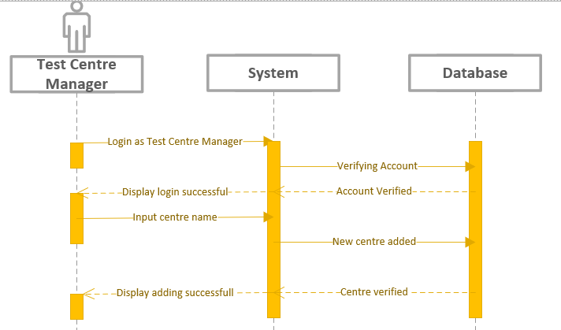

|  |  |
| --- | --- |
| **Cross References** | **Register Test Centre** |
| **Operation** | Login |
| **Responsible** | To get access to page of test centre manager |
| **Pre-conditions** | * The username of user must be available * The password of user must be available |
| **Post-conditions** | * Username are matched according to names in database * Password are matched based on user’s password in database |

|  |  |
| --- | --- |
| **Cross References** | **Register Test Centre** |
| **Operation** | Input Centre Name |
| **Responsible** | To Register Test Centre |
| **Pre-conditions** | * Name of the Test Centre must be available |
| **Post-conditions** | * Test Centre’s name are successfully registered |

2. Record Tester

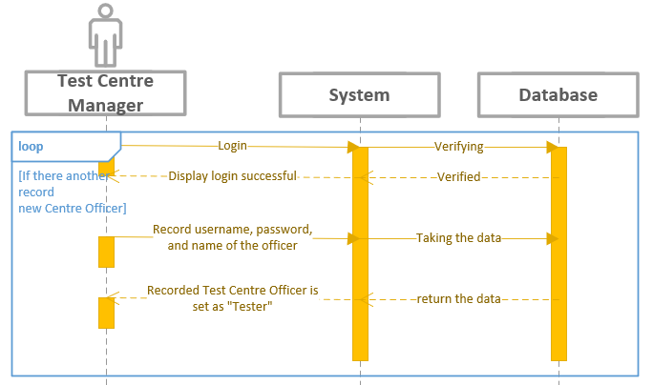

|  |  |
| --- | --- |
| **Cross References** | **Record Tester** |
| **Operation** | Login |
| **Responsible** | To get access page of test centre manager |
| **Pre-conditions** | * The username of user must be available * The password of user must be available |
| **Post-conditions** | * Username are matched according to names in database * Password are matched based on user’s password in database |

|  |  |
| --- | --- |
| **Cross References** | **Record Tester** |
| **Operation** | Set and record the centre officer position as “Tester” |
| **Responsible** | To set the centre officer’s position to “Tester” |
| **Pre-conditions** | * The username of centre officer must be matched in database * The password of centre officer must be matched in database * The name of centre officer must be matched in database |
| **Post-conditions** | * Username are matched according to names in database * Password are matched based on user’s password in database * Name are matched based on user’s name in database * Positions status of the centre officer changed to “Tester” |

3. Manage Test Kit Stock

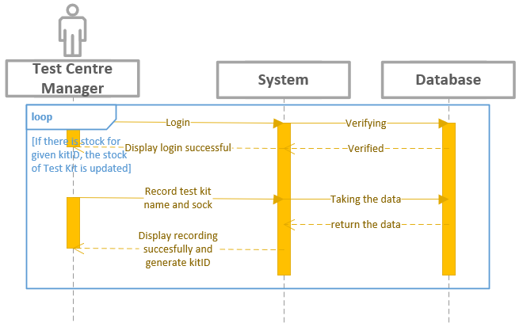

|  |  |
| --- | --- |
| **Cross References** | **Manage Test Kit Stock** |
| **Operation** | Login |
| **Responsible** | To get access page of test centre manager |
| **Pre-conditions** | * The username of usermust be available * The password of user must be available |
| **Post-conditions** | * Username are matched according to names in database * Password are matched based on user’s password in database |

|  |  |
| --- | --- |
| **Cross References** | **Manage Test Kit Stock** |
| **Operation** | Record test kit |
| **Responsible** | To update test kit name and stock |
| **Pre-conditions** | * The name of test kit must available to record * The stock must know many available to record |
| **Post-conditions** | * Name of the test kit and stock are recorded and generate kitID |

4. Generate Test Report

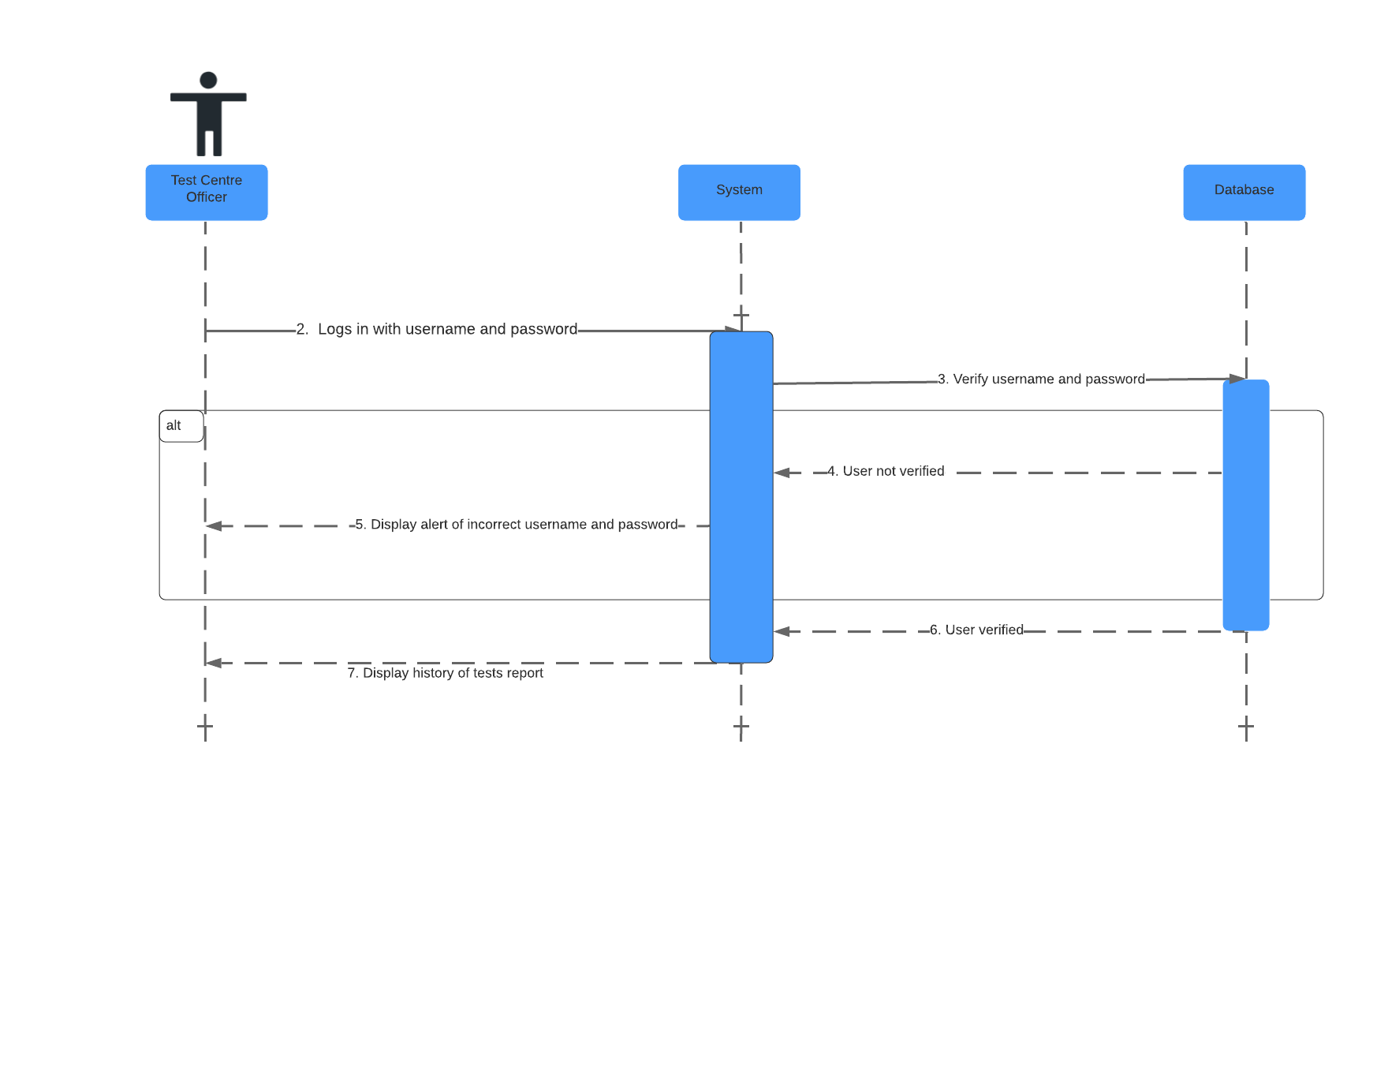

|  |  |
| --- | --- |
| **Cross References** | **Generate Test Report** |
| **Operation** | Login username and password |
| **Responsible** | To get access page of test centre officer |
| **Pre-conditions** | * The username of user must be available * The password of user must be available |
| **Post-conditions** | * Username are matched according to names in database * Password are matched based on user’s password in database |

|  |  |
| --- | --- |
| **Cross References** | **Generate Test Report** |
| **Operation** | Display all history report |
| **Responsible** | To view all history of the report |
| **Pre-conditions** | * The report object must be available |
| **Post-conditions** | * All the report that administered is shown |

5. Record New Test

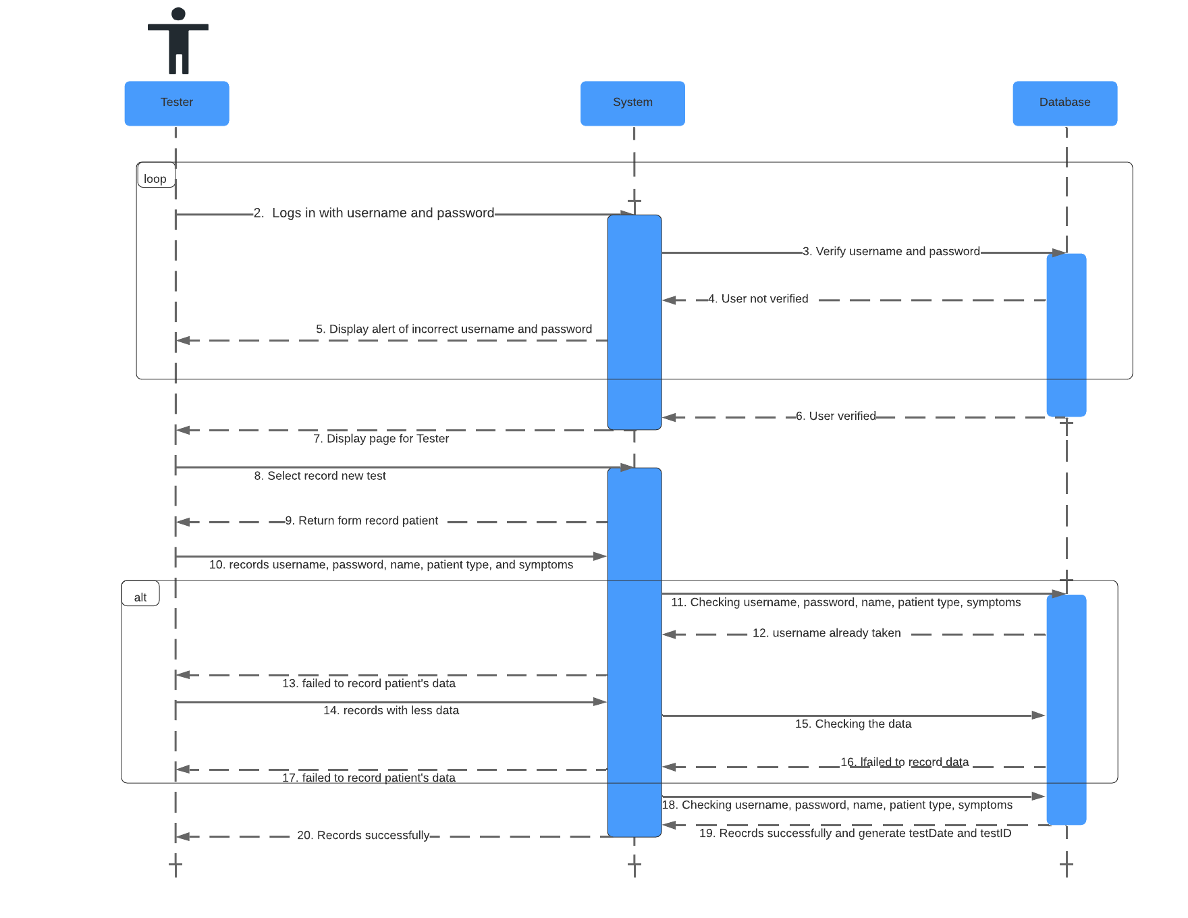

|  |  |
| --- | --- |
| **Cross References** | **Record New Test** |
| **Operation** | Login username and password |
| **Responsible** | To get access page of tester |
| **Pre-conditions** | * The username of user must be available * The password of user must be available |
| **Post-conditions** | * Username are matched according to names in database * Password are matched based on user’s password in database |

|  |  |
| --- | --- |
| **Cross References** | **Record New Test** |
| **Operation** | Select record new test |
| **Responsible** | To get form of new test |
| **Pre-conditions** | * The form object must be available |
| **Post-conditions** | * Succesfully displayed form of new test |

|  |  |
| --- | --- |
| **Cross References** | **Record New Test** |
| **Operation** | Records username, password, name, patient type, and symptoms |
| **Responsible** | To record data of the patient |
| **Pre-conditions** | * The data object must be available |
| **Post-conditions** | * Succesfully record data of the patients * Successfully generate date of test and testID |

6. Update Test Results

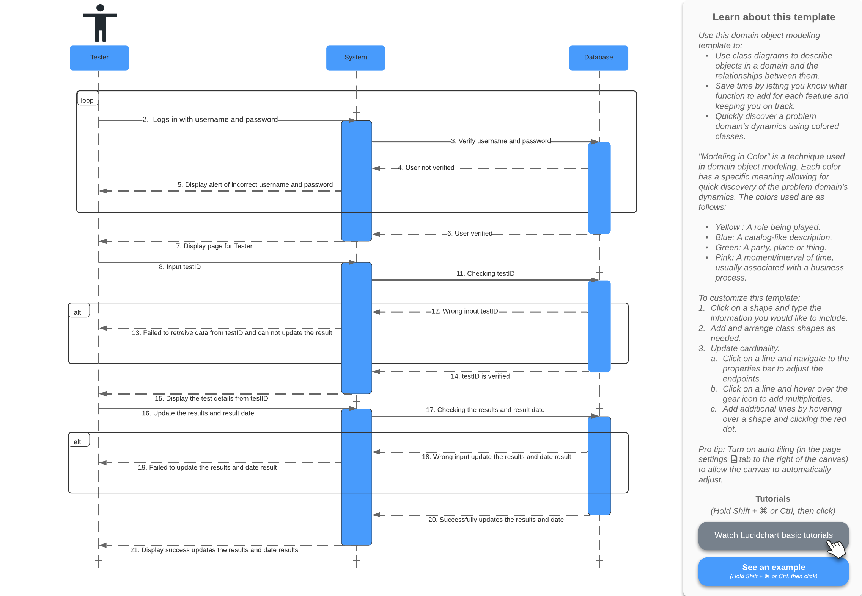

|  |  |
| --- | --- |
| **Cross References** | **Update Test Results** |
| **Operation** | Login username and password |
| **Responsible** | To get access page of tester |
| **Pre-conditions** | * The username of user must be available * The password of user must be available |
| **Post-conditions** | * Username are matched according to names in database * Password are matched based on user’s password in database |

|  |  |
| --- | --- |
| **Cross References** | **Update Test Results** |
| **Operation** | Input testID |
| **Responsible** | To get data test from testID |
| **Pre-conditions** | * The testID object must be available |
| **Post-conditions** | * Successfully display test details from testID |

|  |  |
| --- | --- |
| **Cross References** | **Update Test Results** |
| **Operation** | Input date of test and result test |
| **Responsible** | To update the result of the test |
| **Pre-conditions** | * The date of test and result object must be available |
| **Post-conditions** | * Successfully update date of test and result test |

7. View Testing History

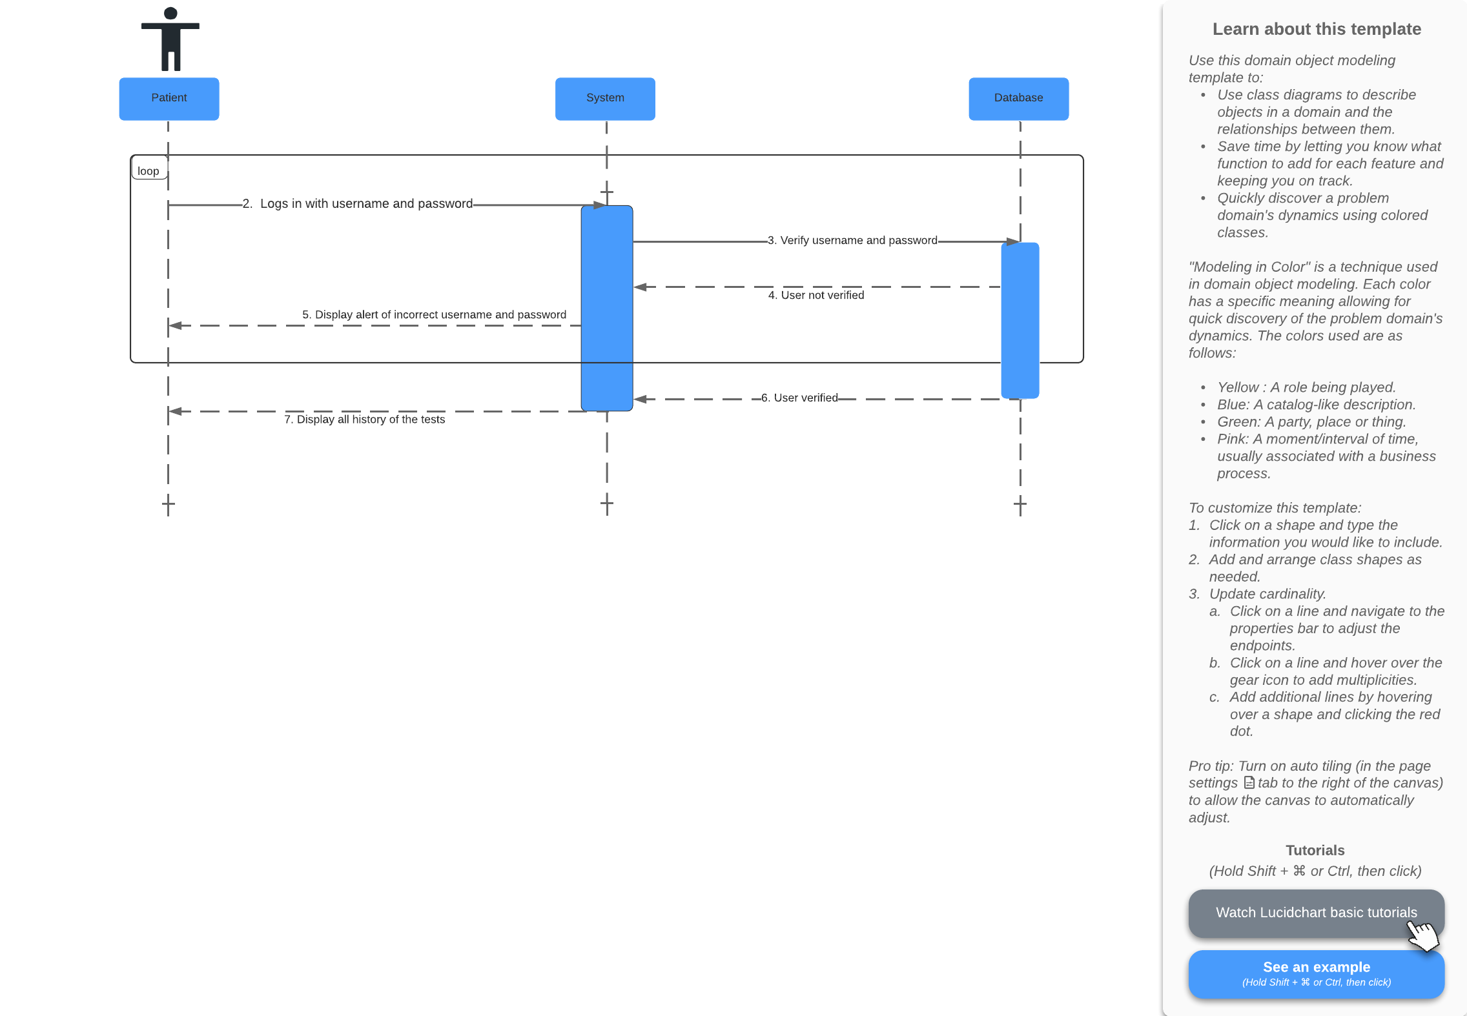

|  |  |
| --- | --- |
| **Cross References** | **View Testing History** |
| **Operation** | Login username and password |
| **Responsible** | To display all history of the tests |
| **Pre-conditions** | * The username of user must be available * The password of user must be available |
| **Post-conditions** | * Username are matched according to names in database * Password are matched based on user’s password in database * Successfully displayed all history of the tests |

8. Login

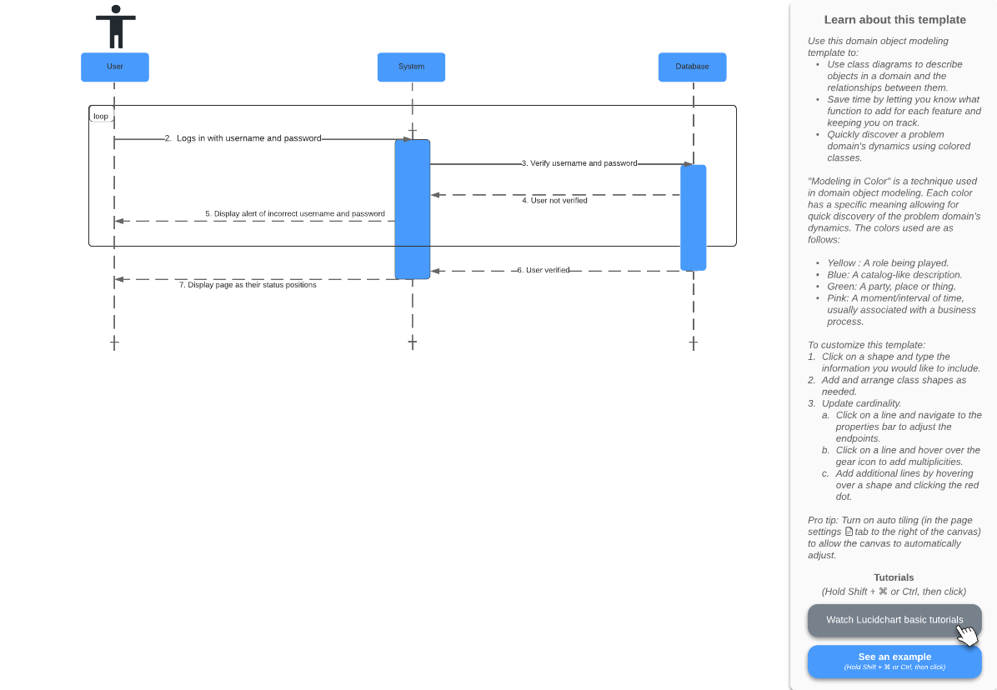

|  |  |
| --- | --- |
| **Cross References** | **Login** |
| **Operation** | Login |
| **Responsible** | To display page as their status positions |
| **Pre-conditions** | * The username of user must be available * The password of user must be available |
| **Post-conditions** | * Username are matched according to names in database * Password are matched based on user’s password in database * Successfully displayed page as their status positions |

References

Athuraliya, Amanda. 2021. What is Sequence Diagram? Complete Guide with Examples. Creately Blog. https://creately.com/blog/diagrams/sequence-diagram-tutorial/